EXPERIMENT 1

- Create a simple cloud software application for Flight Reservation System using any Cloud Service Provider to demonstrate SaaS include the necessary fields such as one way, round trip, From, to, Departure, Departure, Travelers &amp; Class, Fare Type, International and Domestic Flights etc.

AIM

To develop a cloud-based Flight Reservation System using SaaS for easy flight search, passenger details entry, and flight booking management.

PROCEDURE

- Log in to the Zoho One cloud platform.
- Open Zoho Creator from the Zoho One application.
- Create a new application for the Flight Reservation System.
- Create a new form named Flight Reservation.
- Add the required fields:
  - Passenger Name
  - Flight Type (Domestic / International)
  - Trip Type (One Way / Round Trip)
  - From
  - To
  - Departure Date
  - Return Date
  - Travelers
  - Class
  - Fare Type
- Configure the field types according to the data required.
- Design and arrange the form for easy user interaction.
- Save and publish the form.
- Enter sample flight reservation details into the form.
- Submit the form and verify that the entered data is stored in the cloud.
- Test the application by entering different booking details, including one-way, round-trip, domestic, and international flights.
- Verify that the Flight Reservation System works successfully as a SaaS application.

INPUT
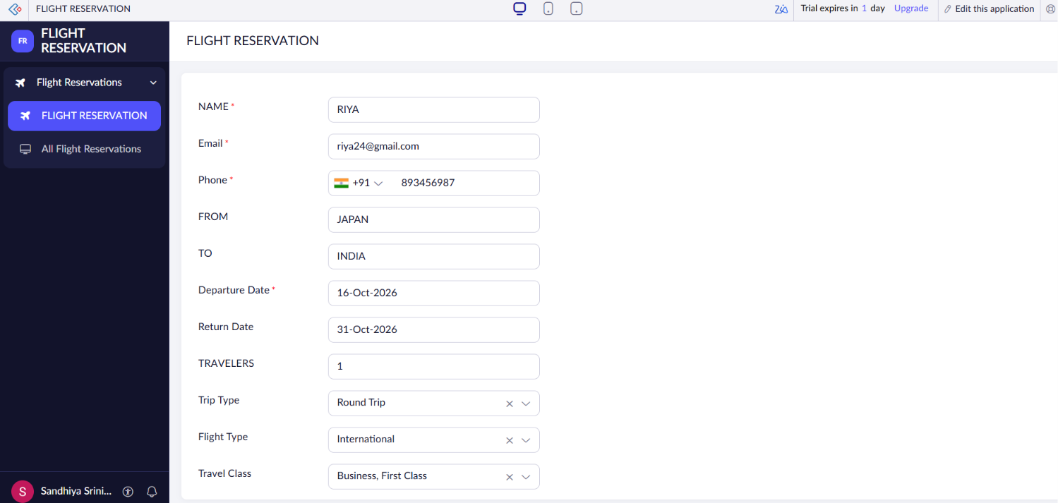

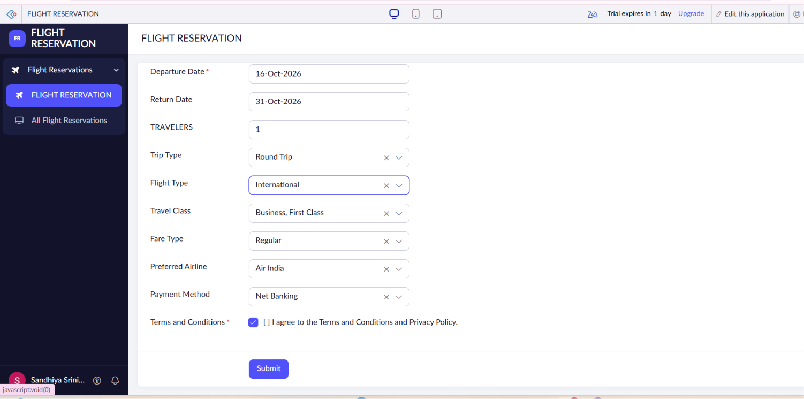

OUTPUT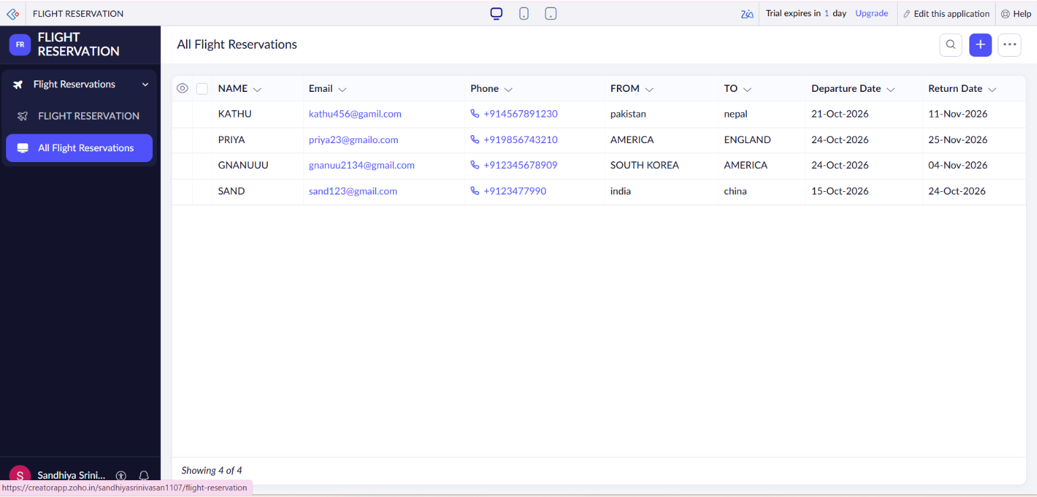

RESULT
Thus, the cloud-based Flight Reservation System was successfully designed to collect passenger details, select flight preferences, and simplify the flight booking process using the SaaS model.

